The thing I learnt in html

Every opening tag has a closing tag

<HTMl></HTML> is the main tag

Within this tag we use <head></head>

<body></body> is use to make body and within there exist various tags that are used for various functions

<hi> This the tag used to make heading </hi> where i=1 to n as I increases the preference of the heading decreases by decreasing the size of the heading and there can be only one h1 that makes a good format but we can have multiple of h2, h3, … as sub heading

<p> is used to make tags that are used to write paragraph the better is <pre></pre> it takes same number of spaces that are provided

<!-- here you can put comment that is not seen the page and is used to make code intuitive -->

<main> </main> is use to demarcate the region of the page and makes it easy to read and help in search engine optimization

<img> is used to add image and it is self closing means we don’t have to put

Src is an attribute in HTML used within a tag and can be added in tag like:

<html>

  <body>

    <main>

      <h1>CatPhotoApp</h1>      <h2>Cat Photos</h2>

      <!-- TODO: Add link to cat photos -->

      <p>Click here to view more cat photos.</p>

      <img src="https://cdn.freecodecamp.org/curriculum/cat-photo-app/relaxing-cat.jpg">

    </main>

  </body>

</html>

alt is another attribute that shows itself when the image is not available so here is an example:

<img src="https://cdn.freecodecamp.org/curriculum/cat-photo-app/relaxing-cat.jpg" alt="A cute orange cat lying on its back">

<a></a> is called anchor tag that can be used to like any link or data and is made visible when we add text after the href tag as :

      <a href = "https://freecatphotoapp.com"></a>

      <a href="https://freecatphotoapp.com">link to cat pictures</a>

NOT ONLY THIS we can also put anchor in <p> or <pre> tags

The attribute target in the <a></a> are use to specify where to open the link eg:

target has various values like

“_blank” opens the linked document or the url in the new tab or the window.

“_self” this default it is the document opens in the same pane as the site.

“_parent” opens the link in the parent frame

“_top” opens the linked doc in the full body of the window

<p>Click here to view more <a href="https://freecatphotoapp.com" target="_blank">cat photos</a>.</p>

Here is how to make a image to a url along with image:

<a href = "https://freecatphotoapp.com"> <img src="https://cdn.freecodecamp.org/curriculum/cat-photo-app/relaxing-cat.jpg" alt="A cute orange cat lying on its back."></a>

To divide the code into the section use the <section></section> now the diff between other sections is that when we have multiple sections and if there is an error in the section and other section run properly the section with error is excluded and rest is reflected as output.

<section>

        <h2>Cat Photos</h2>

        <!-- TODO: Add link to cat photos -->

        <p>Click here to view more <a target="_blank" href="https://freecatphotoapp.com">cat photos</a>.</p>

        <a href="https://freecatphotoapp.com"><img src="https://cdn.freecodecamp.org/curriculum/cat-photo-app/relaxing-cat.jpg" alt="A cute orange cat lying on its back."></a>

      </section>

An unordered list is presented by <ul></ul> it is a list that shows bullet points and now the numbers.

The syntax is using the <li></li> tage we mention the elments within the list eg:

<ul>

          <li>cat nip</li>

          <li>laser pointers</li>

          <li>lasagna</li>

        </ul>

The figure element represents self-contained content and will allow you to associate an image with a caption.

Nest the image you just added within a figure element.

<figure><img src="https://cdn.freecodecamp.org/curriculum/cat-photo-app/lasagna.jpg" alt="A slice of lasagna on a plate."></figure>

To add the caption to the figure using figcaption tag

<figure>

          <img src="https://cdn.freecodecamp.org/curriculum/cat-photo-app/lasagna.jpg" alt="A slice of lasagna on a plate.">

          <figcaption> Cats love lasagna</figcaption>

</figure>

<em>text</em> is a tag used to emphasize the text or it is done in italics we can also use <strong></strong> to make the text bold.

The ordered list is same as an unordered list and the difference being there is a number everytime we make a new item as in counting.

<form></form> is a very powerful tag and is actually used to create forms with various attributes.

action is an attribute in form that tells where the data is to be sent eg:

<form action ="https://freecatphotoapp.com/submit-cat-photo"></form>

Input is an element allows several ways to collect the data from the web and is self-closing.

Type attribute in input is used then type can be different values.

Eg:

<input type="text">

In order to store the value of the input in the action location the we give it a name it is basically storing a variable with value.

But the value of name is the nave of variable basically it is used to reference variable in javascript. If the name is same and we use the radio type then we can select only one value a particular name

<input type="text" name="catphotourl">

Here the catphotourl is the name of the variable

By placeholder we can give some value like giving a hint to what to fill in box.

<input type="text" name="catphotourl" placeholder="cat photo URL">

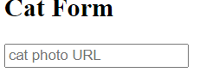

Required attribute in the input makes it compulsory to fill

<button></button> it is used to make buttons and if placed under form it just sends all the inputs to the action location

The type attribute is given here to make clear that it is of submit type.

<button type="submit">Submit</button>

To create a radio button put a radio option

<input type=”radio” value=”the value the present variable denotes”>the value

label elements are used to help associate the text for an input element with the input element itself (especially for assistive technologies like screen readers). For example, <label><input type="radio"> cat</label> makes it so clicking the word cat also selects the corresponding radio button.

Eg

<label><input type="radio"> Indoor</label>

Id attribute is used to identify specific HTML elements. Each id attribute’s must be unique for all attributes from the id in the whole page

          <label><input id="indoor" type="radio"> Indoor</label>

Here is example of label radio button

          <label><input id="indoor" type="radio" name="indoor-outdoor" value="indoor"> Indoor</label>

          <label><input id="outdoor" type="radio" name="indoor-outdoor" value="outdoor"> Outdoor</label>

To group the related inputs and labels together in a web form we use <fieldset></fieldset>

<fieldset>

          <label><input id="indoor" type="radio" name="indoor-outdoor" value="indoor"> Indoor</label>

          <label><input id="outdoor" type="radio" name="indoor-outdoor" value="outdoor"> Outdoor</label>

        </fieldset>

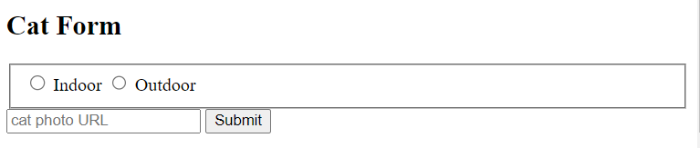

<legend></legend> tag is used to add question to the field set or a kind of caption

See eg:

<legend>Is your cat an indoor or outdoor cat?</legend>



Forms commonly use checkboxes for questions that may have more than one answer.

            <input type="checkbox"> Loving

Another way to put the label for the checkbox is by using the for attribute

<input id="loving" type="checkbox"> <label for="loving"> Loving</label>

TO make the checkbox already checked or the radio button selected by default we add check attribute the place where we put checked is going to be selected by default see the code and example

<fieldset>

            <legend>Is your cat an indoor or outdoor cat?</legend>

            <label><input id="indoor" checked type="radio" name="indoor-outdoor" value="indoor"> Indoor</label>

            <label><input id="outdoor" type="radio" name="indoor-outdoor" value="outdoor"> Outdoor</label>

          </fieldset>

          <fieldset>

            <legend>What's your cat's personality?</legend>

            <input id="loving" checked type="checkbox" name="personality" value="loving"> <label for="loving">Loving</label>

            <input id="lazy" type="checkbox" name="personality" value="lazy"> <label for="lazy">Lazy</label>

            <input id="energetic" type="checkbox" name="personality" value="energetic"> <label for="energetic"> Energetic</label>

          </fieldset>

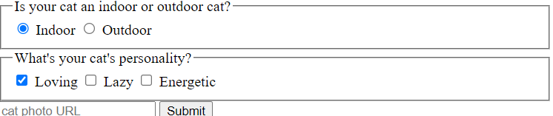

To add a footer section use the <footer></footer> tag

The <title></title> is the title tag that shows in the tab bar about the page.

The lang is an attribute used in html tag that declares the language the page is coded into

Eg:

<html lang="en">

All pages should begin with <!DOCTYPE html>. This special string is known as a declaration and ensures the browser tries to meet industry-wide specifications.

We can set the behaviorby adding the <meta> tag it is a self-closing tag and there are various tags that can be used eg:

<meta attribute="value">

<meta charset="UTF-8">

Check google for more meta behavior types.

<head>

    <title>Cafe Menu</title>

  </head>

When we put title is some of the extra element that make page more readable tho it is not visible on page just like other meta attributes.